**Simulations with Non-idealities**

Simulink model built for the forward converter can be seen in Figure X. The model includes non-idealities in the circuit, namely, voltage drop on diodes, on resistance of the MOSFET, ESR of capacitor and inductor. These are calculated or read from datasheets. Also, transformer magnetizing inductance is calculated as 2mH, and leakage inductance is added in series as 0.3mH.

Duty cycle is adjusted to achieve 10V output for input voltage limits 24V and 48V. For this range, duty cycle range is:

For Vin=24V, D=0.467

For Vin=48V, D=0.227

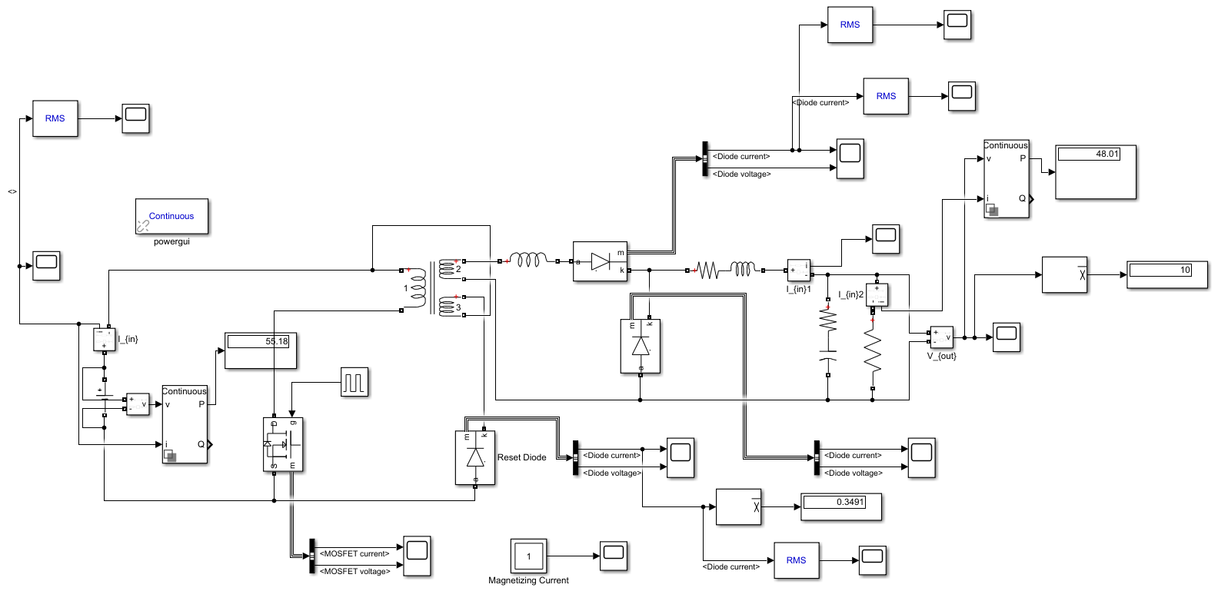

Figure X: Simulink simulation circuit schematic

**Output Voltage:**

Waveforms for output voltage can be seen in Figure X and X. Ripple values can be calculated from these waveforms. Peak to peak ripple as follows:

0.09/10 = 0.9% for Vin=24V

0.12/10 = 1.2% for Vin=48V

Maximum 2% peak to peak ripple requirement is therefore satisfied.

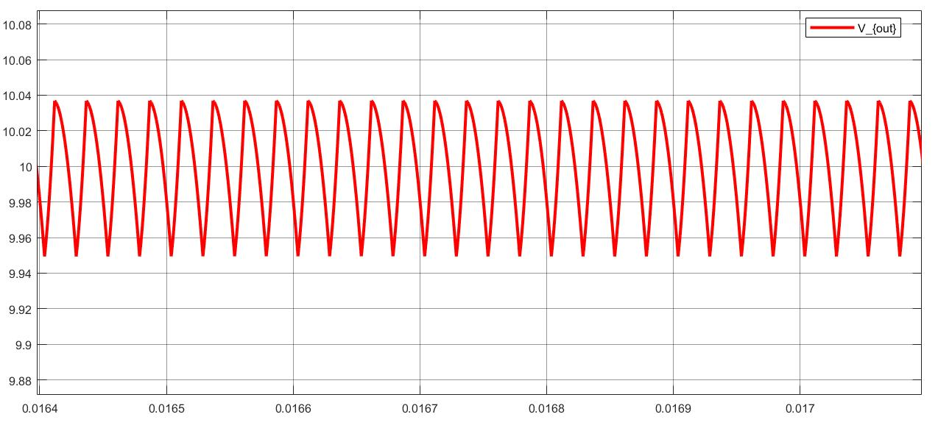

Figure X: Output voltage waveform for Vin=24V

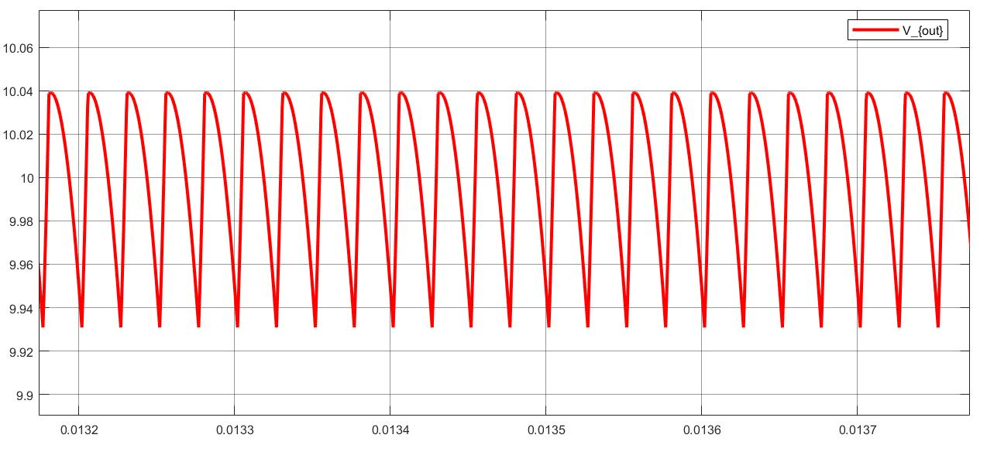

Figure X: Output voltage waveform for Vin=48V

**MOSFET Current and Voltage:**

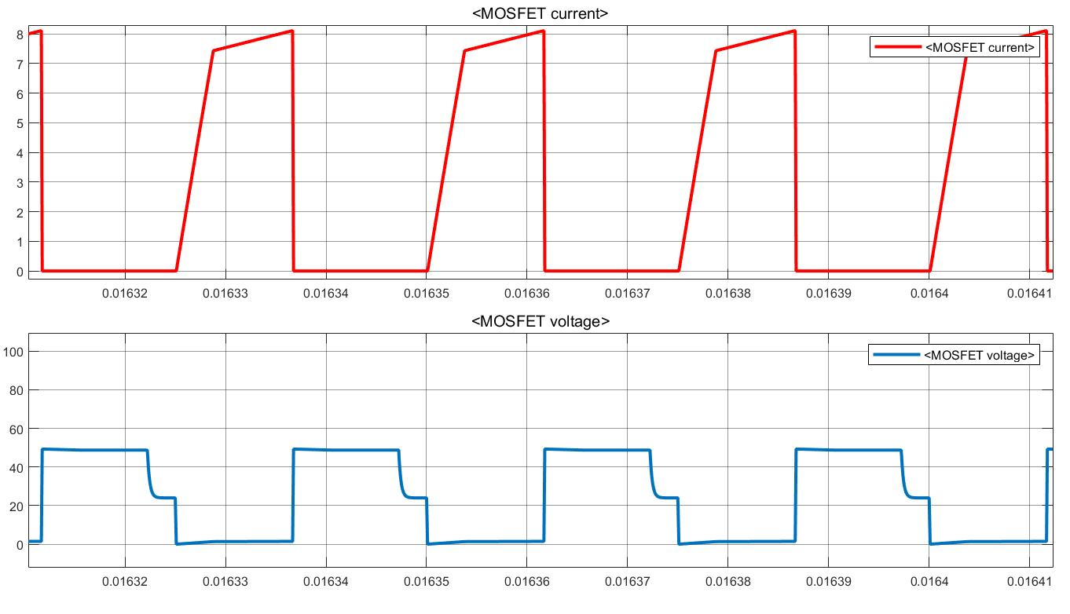

Figure X: MOSFET Current and Voltage waveform for Vin=24V

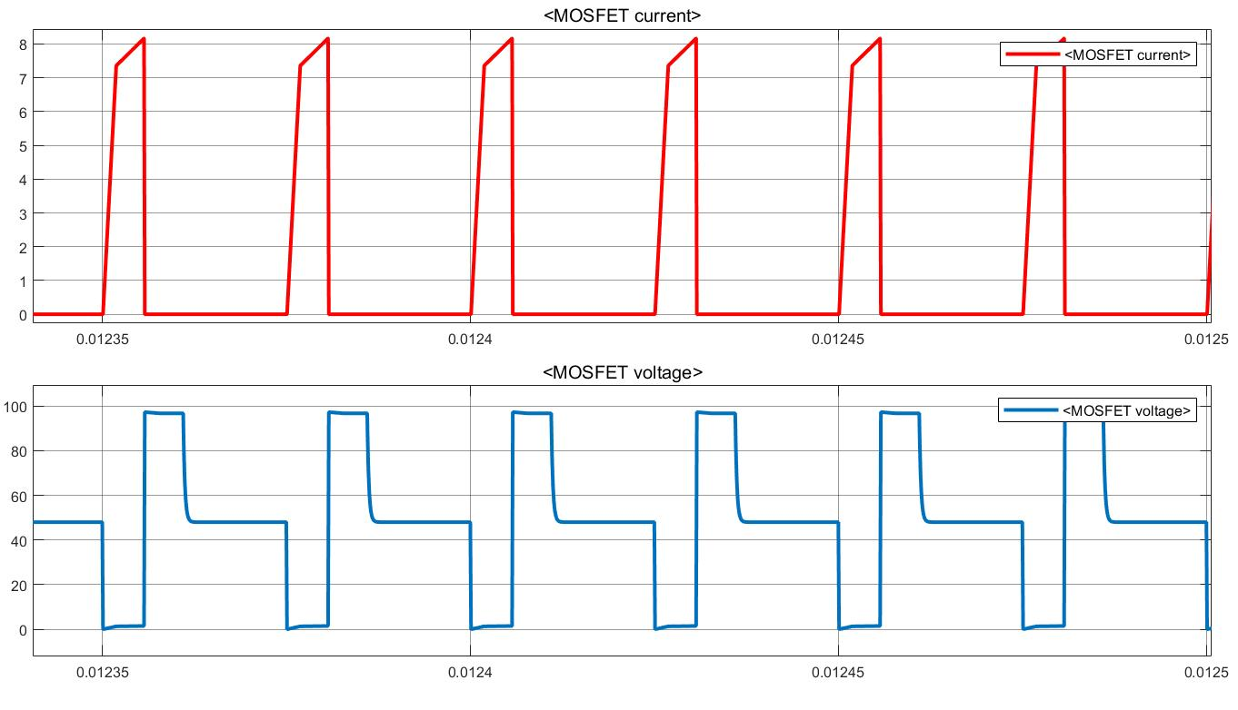

Figure X: MOSFET Current and Voltage waveform for Vin=48V

**Reset Diode Current and Voltage:**

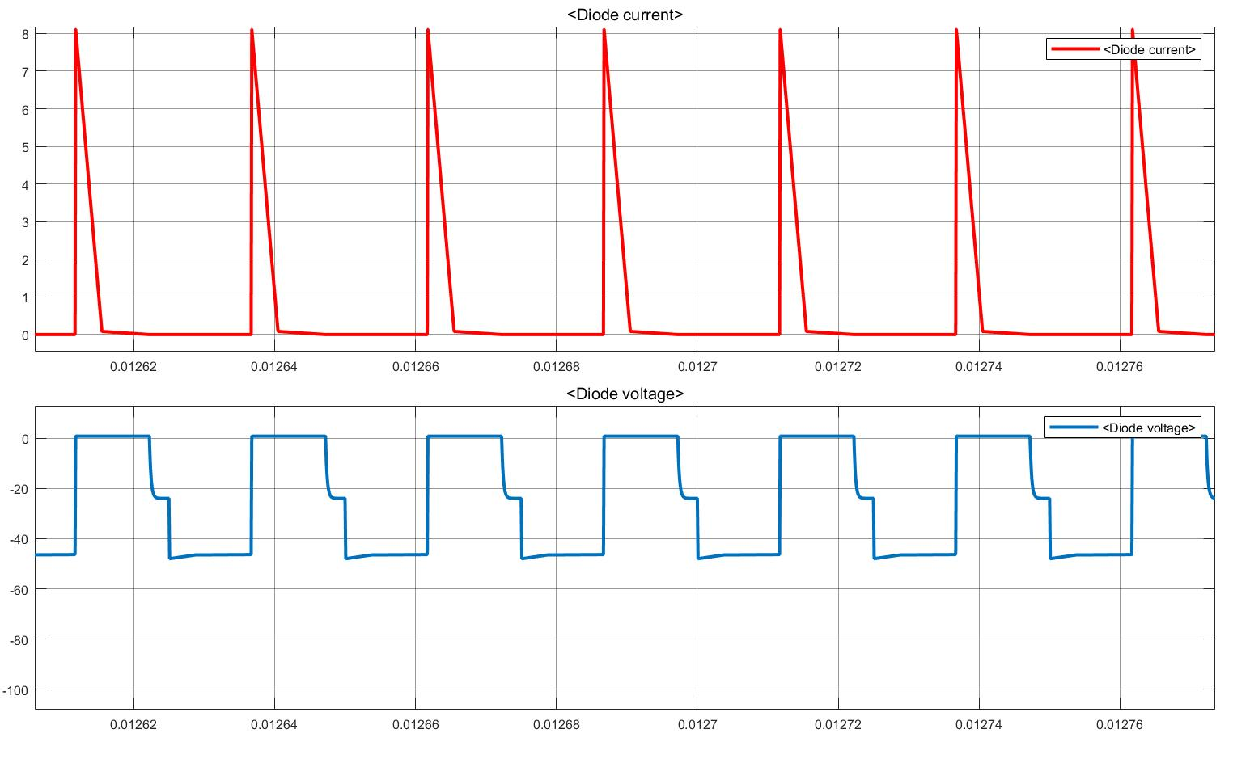

Figure X: Reset Diode Current and Voltage waveform for Vin=24V

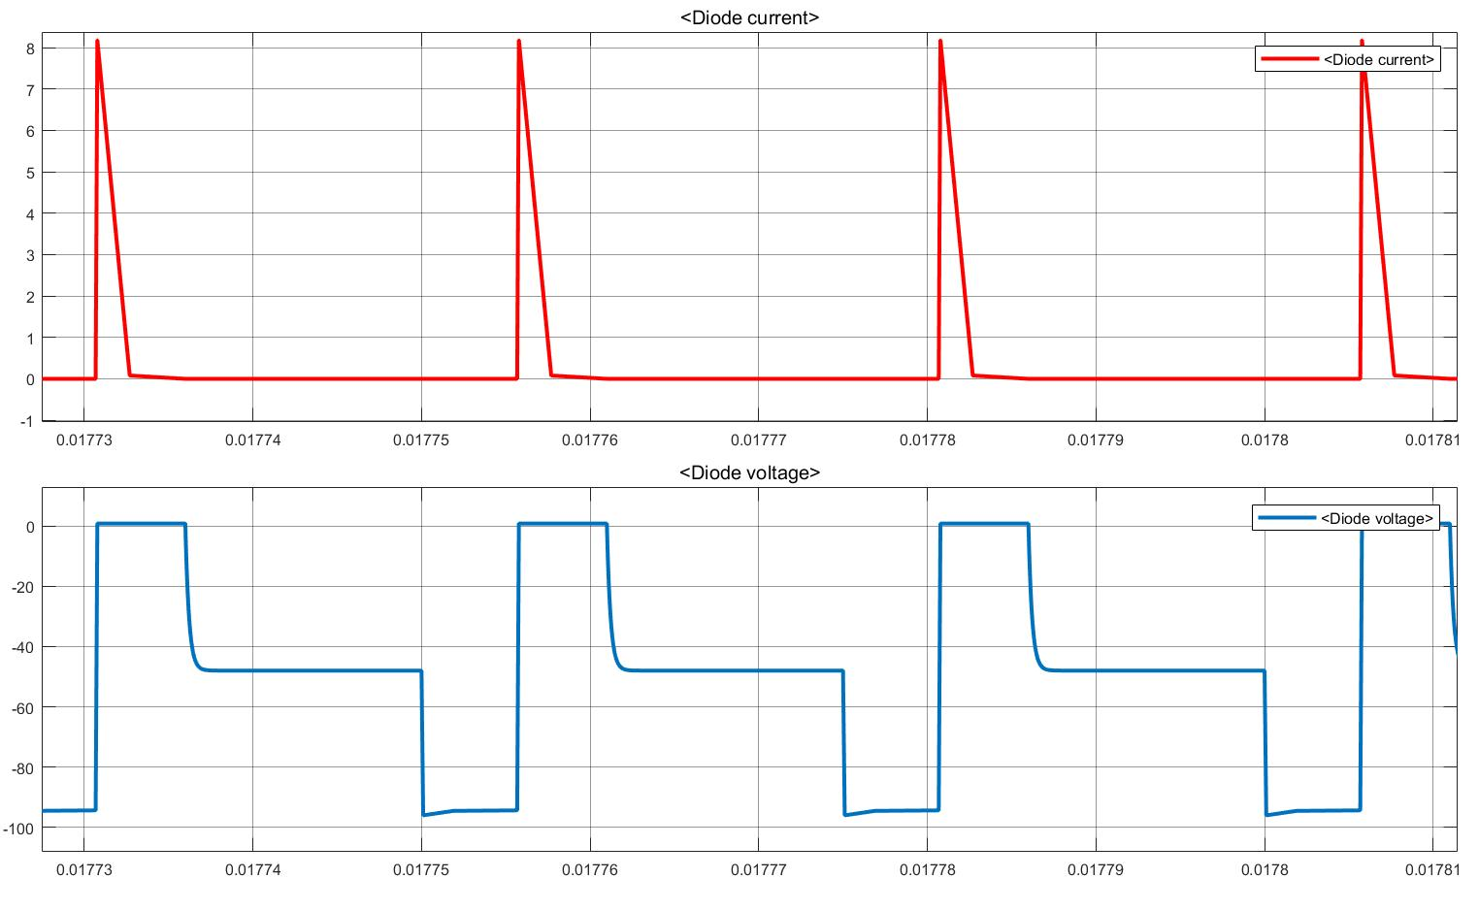

Figure X: Reset Diode Current and Voltage waveform for Vin=48V

**Secondary Diode Current and Voltage:**

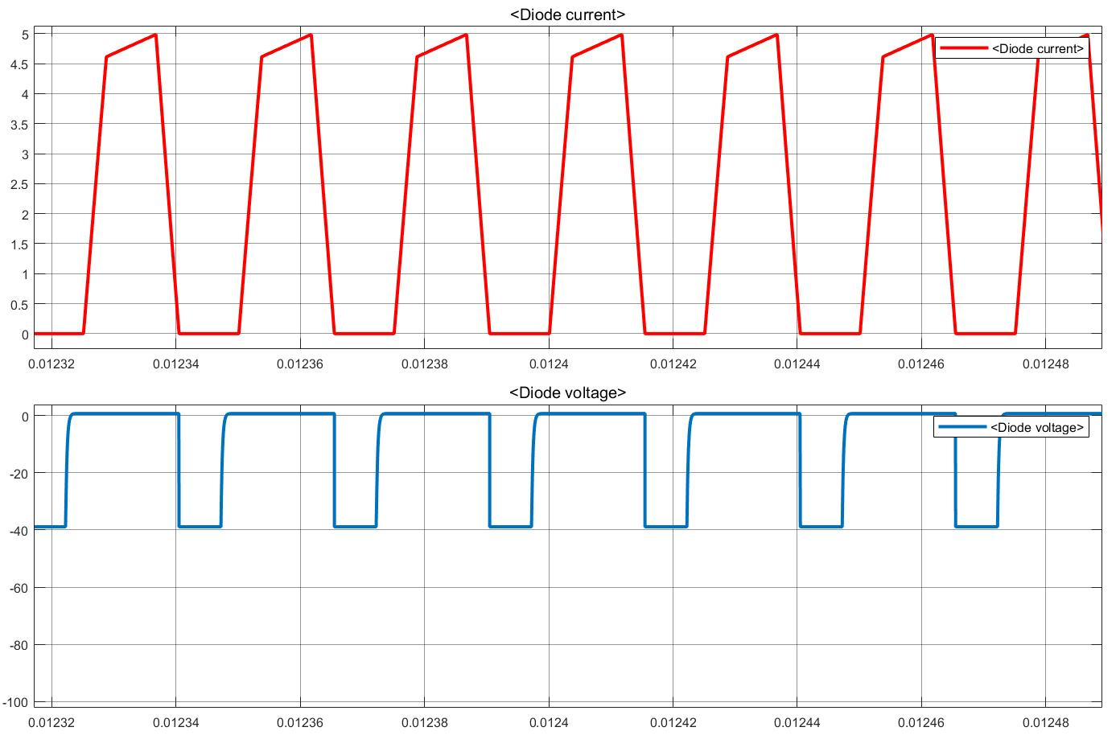

Figure X: Secondary Diode Current and Voltage waveform for Vin=24V

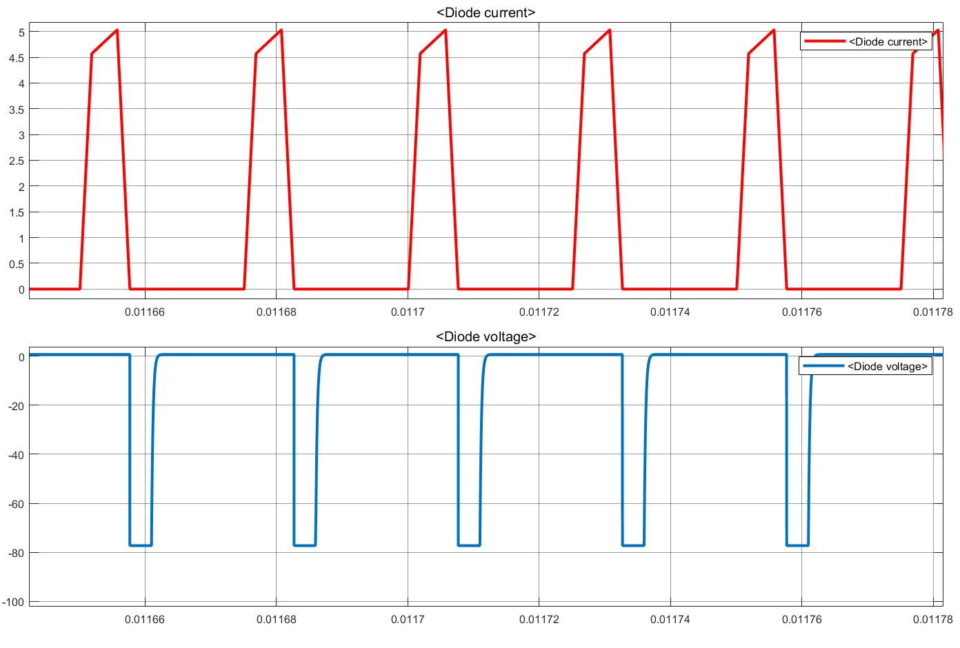

Figure X: Secondary Diode Current and Voltage waveform for Vin=48V

**Free Wheeling Diode Current and Voltage:**

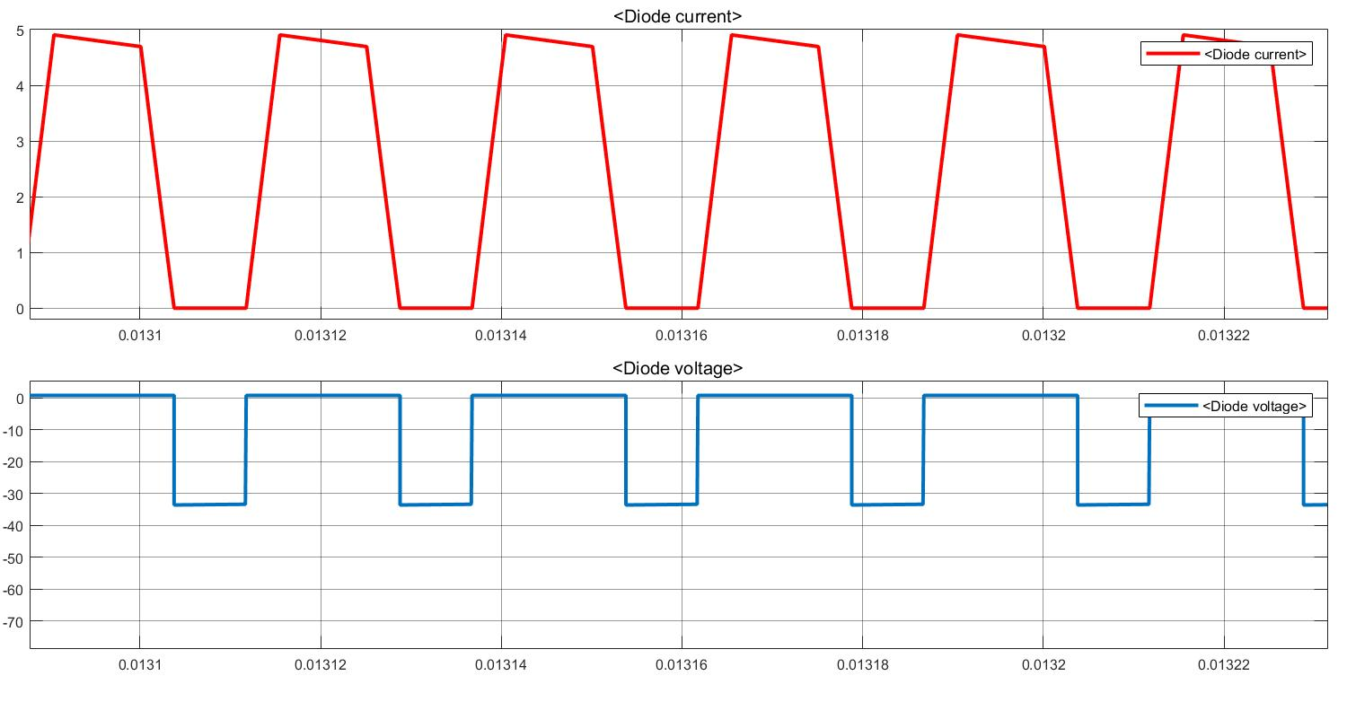

Figure X: Free Wheeling Diode Current and Voltage waveform for Vin=24V

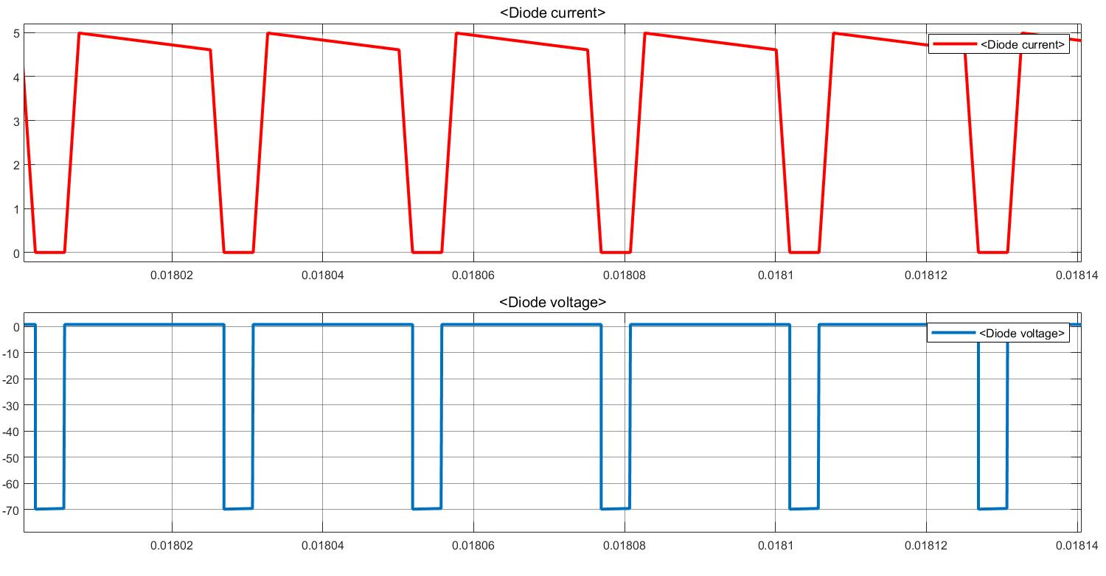

Figure X: Free Wheeling Diode Current and Voltage waveform for Vin=48V